SIMATS ENGINEERING (SAVEETHA SCHOOL OF ENGINEERING) Department of Computer Science and Engineering
ASSESSMENT TOOL 3 – Comparative Analysis
Course Code: | CSA06 | Course Title: | Design and Analysis of Algorithms
CO Assessed: | CO4: Articulation (BL4, BL5) | Assessment: | Assessment Tool 3 – Comparative Analysis
Weightage: | 10% of CIA | Total Marks: | 100
CO4 Statement: | Solve optimization problems using dynamic programming and greedy strategies.
Student Name: | Ishwariya P | Reg. No.: | 192524445
Section / Batch: | 2025 | Date: | 25/8/26

Instructions to Students
• Answer the following question. Total Marks: 100.
• Analyze the given questions thoroughly before answering.
• Compare multiple aspects such as methods, results, advantages, and limitations clearly. • Critically evaluate the strengths, weaknesses, and implications with proper justification. • Present meaningful insights, interpretations, and well-supported conclusions from the comparisons.

Question Type | Focus Area | Questions
Comparative Analysis | Comparative analysis of Dynamic Programming and Greedy algorithms for optimization problems. | Q1

SECTION A – Comparative Analysis
Code of Conduct
I _Ishwariya P(192524445)_________________________ (Name / Reg No) certify that this submission is my original work and that I have adhered to the guidelines specified for this assessment. I understand that any violation of academic integrity rules will result in disciplinary action.
Signature of the Student: _________________________

RUBRICS FOR CALCULATION
Comparative Analysis
Criteria | Weightage | Level 4 (Exemplary) | Level 3  (Proficient) | Level 2  (Developing) | Level 1  (Beginning)
Selection of  Studies/Parameters | 20% | Selects highly relevant and diverse studies with well-defined  comparison parameters | Selects relevant studies with minor gaps in parameter definition | Limited or  partially  relevant  selection | Poor or  inappropriate  selection of  studies
Comparison &  Differentiation | 25% | Clearly compares  multiple aspects  (methods, results,  limitations) with strong differentiation | Good comparison with minor gaps | Basic  comparison  with limited  depth | No clear  comparison;  mostly  descriptive
Critical Evaluation | 25% | Critically evaluates  strengths, weaknesses, and implications with strong justification | Provides  evaluation with  some justification | Limited  evaluation;  lacks depth | No critical  evaluation  provided
Synthesis & Insight Generation | 20% | Generates meaningful insights and conclusions from comparisons | Some insights  derived from  comparison | Limited or  unclear insights | No insights  generated
Clarity | 10% | Information is clearly presented  (tables/figures) with logical structure | Generally clear  with minor issues | Presentation  lacks clarity or structure | Poor  presentation and difficult to  understand

Marks Evaluation:
Criteria | Wt. | Level 4 –  Exemplary | Level 3 –  Proficient | Level 2 –  Developing | Level 1 –  Beginning
Selection of Studies/Parameters | 20%
Comparison & Differentiation | 25%
Critical Evaluation | 25%
Synthesis & Insight Generation | 20%
Clarity | 10%
Total Marks (100):

Faculty In-charge | Course Coordinator | Head of Department
Name: | Name: | Name:
Signature: _______________ | Signature: _______________ | Signature: _______________
Date: ___________________ | Date: ___________________ | Date: ___________________

Aim

To compute shortest paths using Floyd-Warshall for all pairs and Bellman-Ford for a single source, compare their outputs, time complexities, memory requirements, and identify suitable use cases.
Algorithm

Floyd-Warshall

- Initialize the distance matrix using the given graph.
- Set the distance from each vertex to itself as 0.
- Consider every vertex k as an intermediate vertex.
- For every pair (i, j), update:
dist[i][j] = min(dist[i][j], dist[i][k] + dist[k][j]).
- The final matrix contains shortest paths between all pairs of vertices.

Bellman-Ford

- Initialize the source distance as 0 and all other distances as infinity.
- Relax every edge V-1 times.
- For each edge (u, v, w), update dist[v] if a shorter path is found.
- Perform one additional iteration to detect negative-weight cycles.
- The resulting array contains shortest paths from the given source.
Complexity
Algorithm | Purpose | Time | Space
Floyd-Warshall | All-pairs | O(V³) | O(V²)
Bellman-Ford | Single-source | O(VE) | O(V)

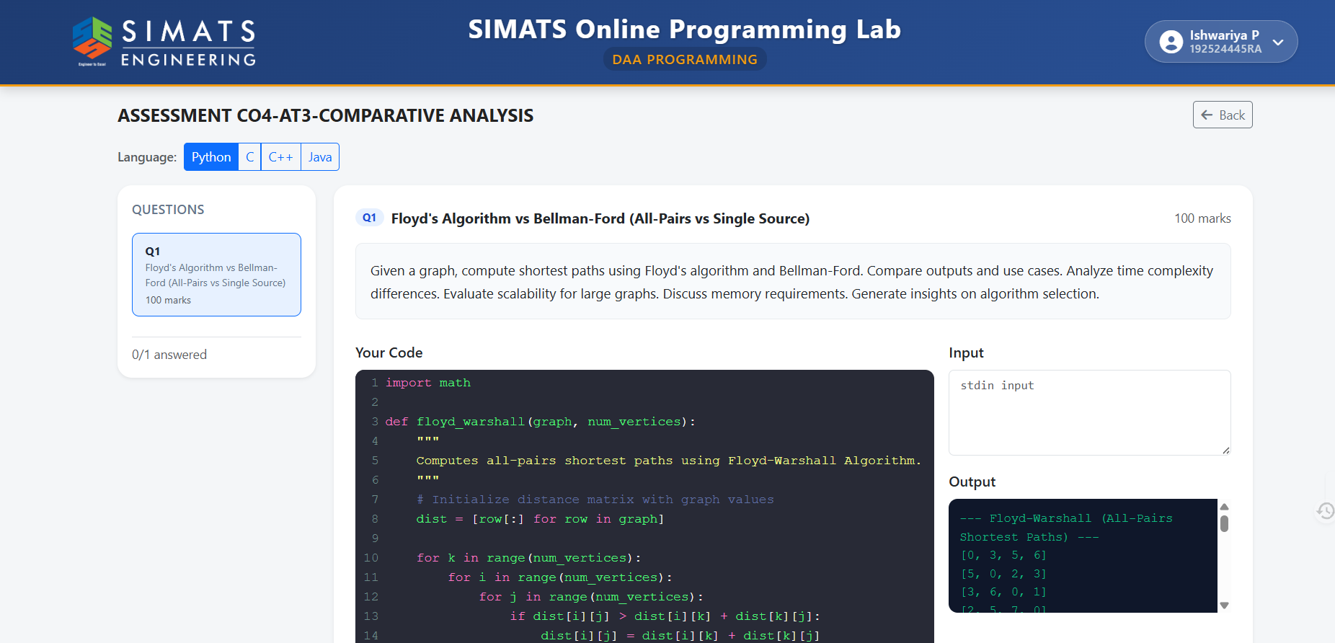

Python Code
INF = float('inf')

def floyd_warshall(graph):
n = len(graph)
dist = [row[:] for row in graph]

for i in range(n):
dist[i][i] = 0

for k in range(n):
for i in range(n):
for j in range(n):
if dist[i][k] != INF and dist[k][j] != INF:
dist[i][j] = min(
dist[i][j],
dist[i][k] + dist[k][j]
)

return dist

def bellman_ford(edges, n, source):
dist = [INF] * n
dist[source] = 0

for _ in range(n - 1):
updated = False

for u, v, w in edges:
if dist[u] != INF and dist[u] + w < dist[v]:
dist[v] = dist[u] + w
updated = True

if not updated:
break

# Check for negative-weight cycle
for u, v, w in edges:
if dist[u] != INF and dist[u] + w < dist[v]:
return None

return dist

# Example graph
graph = [
[0, 3, 8, 7],
[5, 0, 2, 3],
[3, 6, 0, 1],
[2, 5, 7, 0]
]

n = len(graph)

# Convert matrix to edge list
edges = []

for i in range(n):
for j in range(n):
if i != j:
edges.append((i, j, graph[i][j]))

# Floyd-Warshall
fw = floyd_warshall(graph)

print("--- Floyd-Warshall (All-Pairs Shortest Paths) ---")
for row in fw:
print(row)

# Bellman-Ford from source 0
source = 0
bf = bellman_ford(edges, n, source)

print("\n--- Bellman-Ford (Single-Source Shortest Paths) ---")

if bf is None:
print("Negative-weight cycle detected")
else:
print("Source:", source)
print(bf)

Result

For the given graph, the Floyd-Warshall algorithm produces:
--- Floyd-Warshall (All-Pairs Shortest Paths) ---
[0, 3, 5, 6]
[5, 0, 2, 3]
[3, 6, 0, 1]
[2, 5, 7, 0]
For Bellman-Ford with source vertex 0:
--- Bellman-Ford (Single-Source Shortest Paths) ---
Source: 0
[0, 3, 5, 6]

Conclusion: Both algorithms produce the same shortest-path distances for source vertex 0. Floyd-Warshall is preferred when shortest paths between all vertex pairs are required, while Bellman-Ford is more suitable for single-source shortest paths, especially when negative edge weights may exist.

